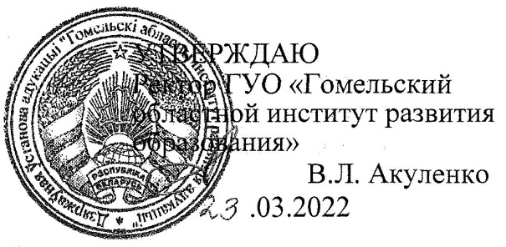

Задания второго этапа областной олимпиады учащихся IV-IX классов
по учебному предмету «Английский язык»
2021/2022 учебный год
VI класс
Part А. Read the text and do the following tasks
A Bad Cent
A man had a very clever dog. That man lived in a small town and everybody knew his dog there. When his friends met his dog in the street they often gave him a cent and the dog took it in his mouth, went to the shop and bought a cake for himself. One day the dog met one of his master’s friends in the street. That man decided to play a trick on the dog and gave him a bad cent. The dog took it and went to the shop. But when the shop assistant saw the cent he didn’t give the dog anything for it. Then the dog took the cent in his mouth again and went to the man’s house. He found that house and entered the room where the man was sitting at that time. The dog put the bad cent on the floor, went away and never took anything from that man again.

I. Define if the sentence is true or false
1. A man had a very foolish dog. ________
2. A few people knew the man’s dog. _______
3. The man’s friends often gave the dog something to eat. ________
4. The shop assistant gave the dog nothing for the wrong cent. ________
5. The dog was pleased to have a bad cent. _________

II. Finish the sentences
1. A dog was ______ .
a) foolish; b) clever; с) stupid
2. The man and his dog lived in ________.
a) a city; b) the country; c) a small town
3. Man’s friends often gave the dog _______.
a) a cake; b) a dollar; c) a cent
4. The dog went to the _______ and bought _______.
a) market, fruits; b) supermarket, a pie; c) shop, a cake
5. The dog ________ for the bad cent.
a) didn’t buy a cake; b) bought; c) not buy

Part В. Lexical-Grammar Test
III. Put the verbs in brackets into the correct form
- Only English _______________________________________________(speak) here.
- Tom is the best pupil. He_______________________________ (be) always the best pupil in his class.
- If the rain__________________________________________________ (not to stop), there____________________________________________________________ (be) a flood.
- Either Helen or Jane ______________________________________________(be) invited to the party.
- The box__________________________________________________________ (bring) two days ago.
- When you ___________________________________________ (phone) me, I _______________________________________________________________(have) lunch.
- –She (come) home yet? __________________________________________________________________________
-I___________________________________ (not to know). I _______________________ (not to see) her today.
- The telephone _________________________________________________ (use) every day.
- We________________________________(begin) as soon as Tom_____________________________________________________________ (be) ready.
- What terrible weather we_______________________________________ (have) now. It___________________________________________________________ (rain) hard.
IV. Use a, an, the where necessary
- ___ Ben Nevis is the highest peak in ___ Scotland.
- Have you ever been to ___ Gobi, one of ___ hottest places on our___ planet?
- Is___ Lake Baikal ___ deepest freshwater lake in the world?
- ___ best salmon is caught near ___Orkney Islands.
5. ___UK is washed by ___ North Sea in ___ west.
V. Complete with correct prepositions
1. Belarus borders ____ five countries.
2. What are you looking ___? - I’ve lost my keys.
3. Last year I took ___ a new hobby.
4. Scotland is famous ___ mountains.
5. Let’s take part ___ this competition.
6. She is keen ___ music.
7. The book consists ___ 300 pages.
VI. Find the mistakes. Circle and correct them
1. Are there some cars in the street?
2. The children is at home.
3. Who is Sally? She is in the park.
4. They didn’t came late last night.
5. She is oldest than her sister.
VII. Put the words in the correct order to make sentences
1. have/we/animals/to/protect/do/rare?
2. town/Belarus/day-off/in/last/visited/we/oldest/the
3. writing/she/something/her/in/is/exercise-book
4. easy/our/the/gave/an/to/test/teacher/class

