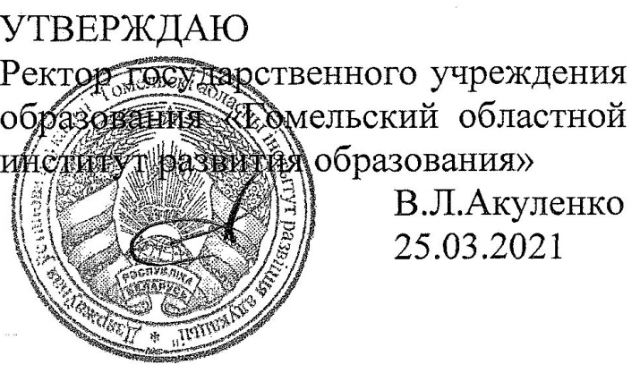

Задания второго этапа областной олимпиады учащихся IV-IX классов
по учебному предмету «Английский язык»
2020/2021 учебный год
VIII класс

Задания | I | II | III | IV | V | VI | VII | VIII | IX | Всего
Максимальное количество баллов за задание | 4 | 1 | 7 | 17 | 7 | 4 | 8 | 12 | 10 | 70
Набранные баллы

Дорогие ребята, выполняйте задания в листах, не делайте никаких других записей, кроме ответов. На выполнение заданий отводится 2,5 часа. Удачи вам!

- Read the article and choose the missing sentences (A-F). There are two sentences which you do not need to use:
Can you imagine what Thanksgiving would be without turkey? As native to the USA as the holiday itself, turkeys have wandered the Americans for ten million years. (1) … . It was accused of making the Cheyenne Indians cowardly. The Hopi plucked its feathers, confident that they had power to bring rain. Other tribes believed that the feathers provided protection, and the Indians would stick them in anthills along their trails to guarantee safe passage. Some northern tribes felt that the turkey battled evil spirits, while other tribes thought it showed them how to plant corn and tobacco. (2) … . But it’s the delicious turkey meat that has made turkeys popular among all Americans over the years. Wild turkey was served at that first Thanksgiving meal at Plymouth Colony. (3) … . So, in order to guarantee a source of turkey meat, the bird was eventually domesticated, and breeders tried to produce larger and larger turkeys, quite different from the wild turkeys the early settlers were familiar with. Wild or domesticated, the turkey was so important in the early days of the United States that Ben Franklin wanted to make it the official United States bird. When the bald eagle was chosen instead, he said, “I wish the bald eagle had not been chosen. (4) … . The turkey is a much more respectable bird and withal a true original native of America”.
- He is a bird of bad moral character.
- Most Indians used turkey feathers in their headdresses and on their arrows.
- Historians believe that turkey were brought to America by white settlers form their native lands.
- Finally, large farms appeared producing large quantities of turkey meat.
- To the settlers, it wasn’t just a treat – it was one of the foods upon which they depended.
- Historians say that many Indian beliefs originated from the wild turkey.

- Choose the best title for the text:
- Turkey Versus Eagle: Who Wins?
- A Two-wing Symbol of America.
- The Truly American Bird of Feather.
- A Word about Thanksgiving Dinner.

III. Complete the second sentence so that it has a similar meaning to the first sentence using the word given. Don't change the words given.
- They crossed the Atlantic in three days. (them)
It _____________________________________cross the Atlantic.
- Learning new words isn’t easy for me. (find)
I _____________________________________new words.
- Could I borrow your bike this week? (me)
Would ____________ your bike this week?
- “Let’s go out for a meal”, Jane said to me. (suggested)
Jane _________________________a meal.
- He lived in London once, but he doesn’t any more. (used)
He ______________________________ in London.
- Three hundred students entered the swimming competition last year. (part)
Three hundred students ____________________________ the swimming competition last year.
- Physical exercise won’t hurt you if you are careful. (do)
Physical exercise won’t ____________________________ if you are careful.

IV. Fill in the articles where necessary:
In (1) _____ central square of (2) _____ London there is (3) _____ tall column with (4) _____ monument on it stop. It is (5) _____ monument that is famous all over (6) _____ world. (7) _____ Admiral Nelson was born on (8) _____ 29th of (9) _____ September in 1758. During his life he took part in (10) _____ lot of sea battle sand as (11) _____ luck was usually on his side, he won. He was (12) _____ real genius. He fought in (13) _____ Atlantic ocean and in (14) _____ Pacific ocean and never lost (15) _____ single battle. Not once did he save (16) _____ pride of (17) _____ United Kingdom.

V. Put the verbs in brackets into the correct tense forms:
Most people take time off work to travel, but for Ian Wright making a living requires travelling. Ian, who (1. travel) __________________ around the world many times, is one of the presenters of Globe Trekker — a popular TV series which (2. explore) __________________ the sight sand sounds of different countries.
Since he (3. give) __________________ the job as a presenter on British TV, Ian (4. participate) __________________ in over 50 episodes of the show, visiting countries like Ethiopia, Cambodia, Jamaica and Iran. On his travels, I an often (5. try) __________________ local food and sometimes exposes himself to danger. Once, while filming in the Pacific, he (6. hit) __________________ by a block of lava. "In Vanuatu we visited the most accessible volcano of the world. It erupted every ten minutes, spitting out lava all over the crater. It was unbelievable — until the wind changed. A piece of lava landed two meters away from my head. And we ran crying like babies."
Although Ian (7. make) __________________ Globe Trekker episodes for many years, he is as enthusiastic as ever!

VI. Match the phrases or situations (1-4) with the correct responses (A-E). One response is extra:
1. I must be off now.  2. It's good tọ see you again.  3. It seems a longtime since I saw you last.  4. I'm crazy about football. | A. Yes, time flies.  B. See you soon then.  C. Me too.  D. Delighted to see you too.  E. I'll see.

VII. Fill in the prepositions where necessary:
- There are so many people in the street. I wonder what’s going _______________?
- I don’t think he will get __________________ his mother’s death so easily.
- The waiter had a little difficulty _____________ understanding the foreign language.
- You are the only one I trust. Please, don’t let me __________________.
- Please, don’t be angry _______________ me! I didn’t think to do so.
- Would you, please, turn__________________ the volume? It’s too loud.
- I’m sorry, I’m ___________ hurry. Let’s discuss it next time.
- What time did the train arrive ______________ St. Petersburg?

VIII. Use the word in brackets to form a word that best fits each gap:
1)__________________ (FISH) or sailors sometimes claim to have seen monsters in the sea. Though people have willingly listened to stories told by seamen, it is now 2) __________________ (KNOWLEDGE) that many of these “monsters” are 3) _________________ (SIMPLIFY) strange fish. 4) ___________________ (OCCASION), unusual 5) _________________ (CREATE) are washed to the shore, but they are 6) __________________ (RARITY) caught out at sea. Some time ago, however, a 7) ____________________ (PECULIARITY) fish was caught near Madagascar. A small fishing-boat was carried miles out to sea by the 8) _________________ (POWER) fish as it pulled on the line. When it was brought to shore, it was found to be over 13 feet long. The fish is being 9) __________________ (EXAM) by 10) __________________ (SCIENCE) now. Such things have hardly ever been seen 11) ___________________ (LIVE) by a man as they live at a 12) _____________________ (DEEP) of six hundred feet.

IX. Read the text below and choose the correct word for each space. For each question, mark the correct letter a, b, c or d:
Tweetie de Leon-Gonzalez 1) _____________ in to the competitive world of modelling at the age of 14. Advertisers 2) ________________ notice, but she was not easily 3) ________________ from getting her education. She accepted modelling projects but made 4) ____________________ these were only at weekends. With a discipline that would make any parent proud, this hard-working student 5) ________________ high school and then 6) ____________________ a university degree in philosophy. After graduating, Tweetie went job-hunting, but modelling projects continued to come her way, until her days were ail 7) ___________________ up. It was only after 8) _________________ a competition that she decided to 9) __________________up modelling as a profession. Yetatt he height of her popularity, she turned her back on the glamour of the fashion world because she was finding modelling less and less 10) _________________. She said it was beginning to feel more like work than enjoyment.

- a) threw b) started c) broke d) launched
- a) took b) got c) made d) saw
- a) disturbed b) distracted c) interested d) interrupted
- a) definite b) careful c) clearly d) sure
- a) stopped b) finished c) ended d) concluded
- a) awarded b) made c) passed d) got
- a) taken b) booked c) given d) made
- a) taking b) gaining c) winning d) going
- a) get b) take c) give d) spend
- a) rewarding b) boring c) tired d) interested

